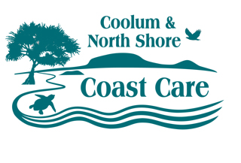
Coolum and North Shore Coastcare
157 Warran Road,
Yaroomba, Qld, 4573
Ph. 07 5446 1600
ABN 32 962 214 127
www.coolumcoastcare.org.au

Membership application / renewal form

Subscriptions are paid annually and are due on 1 April

New member Renewal

APPLICANT DETAILS

First name |  | Surname
Address

Home phone |  | Mobile
Email

PAYMENT DETAILS
Send to: Coolum and North Shore Coast Care
157 Warran Road
Yaroomba, 4573

Or deposit Bank: National Australia Bank
Account Name: Coolum District Coastcare Group
BSB: 084620
Acc Number: 529312346

If paying by EFT or directly into the account, be sure to include your name as the payment reference

Annual Fee | $10.00
Donation | $
Total | $

_____________________________________________________________________________________
for New members only:

I apply to be an ordinary member of Coolum District Coast Care Group Inc.
I declare that I am over eighteen years of age.
I agree to abide by the rules of the association.

Applicant signature: ………………………………………………Date…………………………………….

Member proposer: ………………………………………………Date…………………………………….

Seconder: ………………………………………………Date…………………………………….

Approved by: ………………………………………………Date…………………………………….

AREAS OF INTEREST (Please tick)

Community conservation, planting and weeding: | Coolum Beach |  |  | Marcoola
 | Lions Park Watercourse |  |  | Marcoola North
 | Yaroomba
Coolum Community Native Nursery |  | Social events – planning, organising, attending |  | Education and awareness – school groups, public events
Community group organisation, planning |  | Environmental advocacy |  | Administration, web design, social networking
Other (please specify)

